AATC_Crypto
The AATC_Crypto module manages the encryption between a server and a client. As the information transferred could be used to immitate a user, monitor or drone and control/access information using this account or read the information from the data sent in plaintext between the server and the client. In order to prevent this the AATC_Crypto module wraps around the socket connection on both ends in the send and recv functions, encrypting and decrypting the communications of the client using AES-GCM. AES is used instead of other ciphers such as 3DES as it is still considered secure and most modern (since ~2011) x86 processors have hardware acceleration for AES which can provide large performance improvements over encryption in software. AES-GCM is used over ECB due to ECB revealing details about the plaintext due to each identical block having the same output. However as GCM is a counter cipher, a counter is used in addition to a key to encrypt the plaintext, if the communcation is interupted and the number of send and recvieves do not match for the client and server decryption will fail, requiring a reconnection to the server. IV = Initialisation Vector , required for GCM and reduces chances of patterns occuring in the ciphertext.

AATC_Crypto has three main modes, preshared AES keys, preshared root RSA certificates and automatically generated RSA certificates.
Preshared AES keys use preconfigured keys in AATC_Config to setup the AES object and must be the same for the server and client. This means that anyone who can connect to the server can also decrypt all the communications for that server , leading to a servere vunrability should one client be compromised. Furthermore if these keys are to be changed they must be changed for all clients at the same time and any outdated clients would not be able to connect.
Automatically generated RSA keys are more secure under most conditions , the client generates a new RSA key pair and passes the public key to the server. The server generates a random AES key and IV and encrypts these with the public key and sends the result back to the client, which only the client can decrypt. This method is vunrable to the Man in the Middle attack , where another person intercepts the communication between the client and the server and performs the same authentication proceedure for both, immitating both the server and the client towards the client and server respectively , resulting in the ability of the middle man being able to read the communications between the server and client in plaintext. This vunrability stems from the fact that the client does not authenticate the server and so anyone could immitate the server.
The RSA certificate system will be described in more detail in AATC_CryptoBeta. The procedure effectively uses a certificate to verify the server and uses the certificate to pass the encrypted messages to initialise the key and IV.

Note:
PreSharedKeys does not mean the same as SetEncryptionKeys, PreSharedKeys use preshared certificates with public keys to generate new keys while SetEncryptionKeys use permenantly set keys.

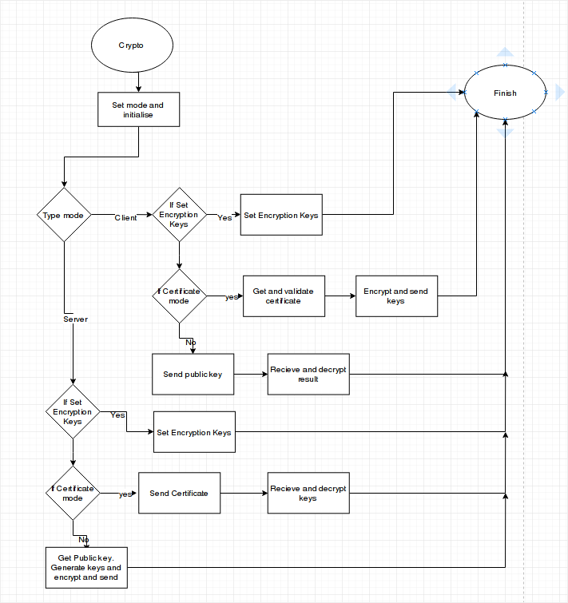

Import

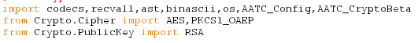
The module requires a number of different modules in order to function. Codecs,recvall and ast are used to communicate with the other side of the socket. Binascii and os are required to generate cryptographically random numbers. AATC_Config is required for configuration and AATC_CryptoBeta is required for the certificate system.

Crypter
The crypter class is the main class in AATC_Crypto. It is used as a simple method to setup and perform encryption for sockets automatically, storing all encryption and decryption objects and parameters.

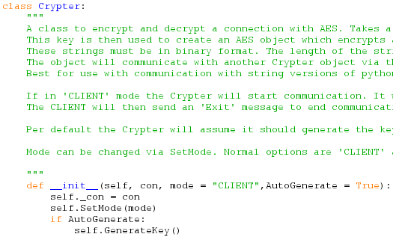
When instansiated the crypter object requires one parameter and takes two optional parameters. The required parameter is a connection object , used to setup the encryption parameters automatically. The mode paramter sets if the current side will either be CLIENT or SERVER in the setup procedure. Auto generate defines if the keys should be generated automatically or should wait for the GenerateKey method to be called.
The connection and mode are set as attributes and if AutoGenerate = True the keys are generated.

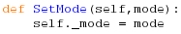
The SetMode method takes a mode and sets the mode attribute to this value.

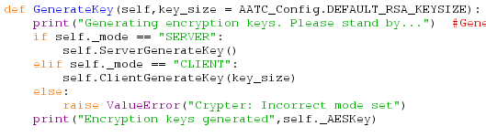
The generate key method is used to start the setup of the encryption keys, taking one optional parameter of the RSA key size for the autogenerated RSA key method. The function relevant to the mode is called using the if statements, if the mode is incorrectly setup an error is raised. Finally the encryption key is displayed.

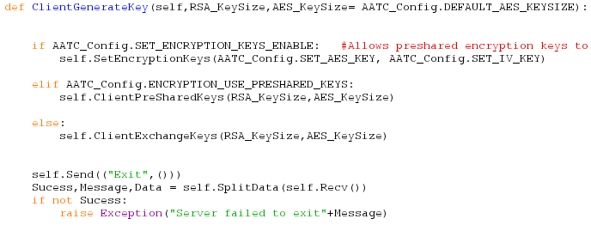
ClientGenerateKey is used to start the relevant key generation as setup in the AATC_Config file , taking two arguments, RSA key size and AES key size. If Preshared AES keys are setup they are set using SetEncryptionKeys. If The Encryption_Use_Preshared_Keys value is true then the method calles the ClientPreSharedKeys method passing the RSA and AES key sizes. If none of these options were enabled the ClientExchangeKeys method is called with the RSA and AES key sizes.

The method then sends an exit command to the server to signal completion of the setup process and checks for a response, if this is false it raises an exception due to a failed setup proceedure.

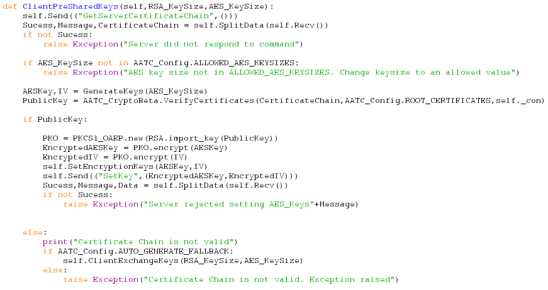
The PreSharedKeys method is a way to distribute keys securely with a reduced probability of a Man in the Middle attack occuring. The method refers to the preshared root certificates which are distributed to each client. The system works using RSA certificate signing and is explained in greater depth in the AATC_CryptoBeta module. The general system works by the Server obtaining a valid certificate chain from the RootCA , which also includes a private key. The server sends the chain to the connecting client who checks if the chain is valid. If not the connection is stopped ( unless set otherwise) , if it is valid the public key is extracted and used to securely send the AES and IV keys to the server who can decrypt them.

First the client requests the servers certificate chain. This is returned in the form success, message and CertificateChain. If success is false the client assumes the server is not functioning correctly ( did not recognise the command) and so raises an exception to cancel the connection. Otherwise the client checks that the client side set key is in the allowed values , raising an exception if it is not.
Should all continue correctly the server will then generate the encryption keys. Then the certificate chain is validated by the the CryptoBeta module using the Root certificates defined in the Config file as well as the connection object. Should there be a discrepancy the function will return False, otherwise it will return the public key.
If the public key is returned the main key exchange can take place. First a new RSA encryption object is created in the PKO variable. This object is used to encrypt the AES and IV keys, making it unreadable to anyone without the public key. The encryption keys on the client side are set using SetEncryptionKeys. The SetKey command is sent to the server with the encrypted keys , the response is received. If this occurs correctly ( success = True) the program will continue, if not an exception will be raised ( the server was not able to comply with setting of encryption keys e.g. incorrectly setup key lengths).
If the public key fails for some reason i.e. an invalid certificate, it is possible to fall back on the auto generated keys. If the AUTO_GENERATE_FALLBACK flag is set to True in AATC_Config the server will attempt to generate these keys using the ClientExchangeKeys method, if the flag is set to false then the program raises a relevant error.

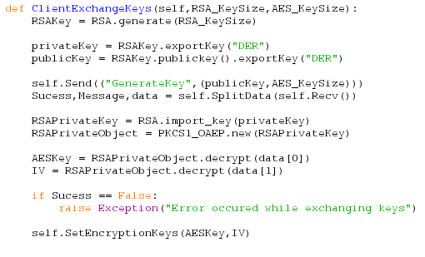
Client Exchange keys is the method used to automatically create new RSA keys in order to encrypt the communications to pass the AES encryption keys to the relevant participants. The method takes two parameters, RSA_KeySize and AES_KeySize, reflecting the size of each of the keys to be generated. First a new RSA key is generated and the relevant key pair derived from this, privateKey and publicKey. The client sends the public key and requested AES key size to the server using the GenerateKey command. The server responds with the Encryption keys encrypted with the public key, allowing only the Client to decrypt the message. These keys are extracted using the RSAPrivateObject decryption object and the keys set. Should the success message be false an exception will be raise i.e. server failed to set the encryption keys to the key exchange process cannot continue. Finally if the program suceeds the encryption keys are set.

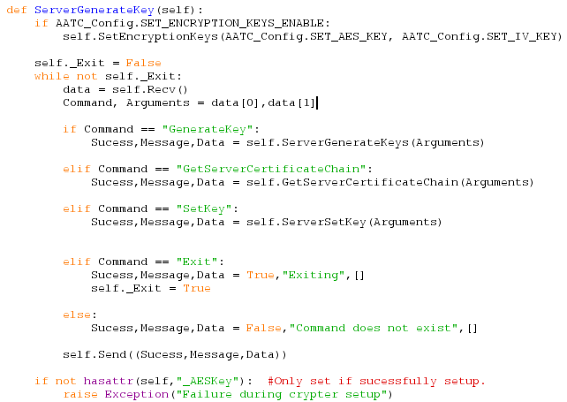
The ServerGenerateKey method is used by the server in order to handle the key exchange process. The method acts like a mini AATC_Server loop , allowing the client to repeatedly send commands and processes these commands. Prior to the main loop if the SET_ENCRYPTION_KEYS_ENABLE flag is set to True the Set encryption keys are loaded and set.
The loop continues until _Exit is set to True. The program receives the command and arguments from the client , executing the relevant command or returning the failure message if the command does not exist.

GenerateKey → Automatic RSA key generation, server encrypts using public key
GetServerCertificateChain → Send the server certificate chain
SetKey → Set the passed keys as the encryption keys encrypted using the RSA chain.
Exit → Exit the loop

At the end of the loop the program checks if the Crypter object has setup a _AES _ key value which would indicate that the program has correctly been setup.

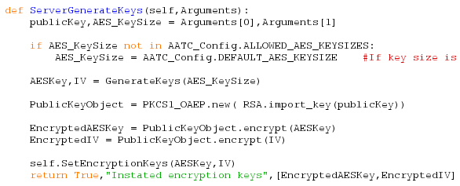
ServerGenerateKeys is used as part of the automatic RSA key generation scheme. It takes one argument, a tuple containing the public key and the AES_KeySize. The public key and AES_KeySize are extracted and the AES_KeySize checked if it matches an allowed value, if it does not the KeySize is set to the default key size, overriding the users choice. The AES and IV keys are generated and encrypted using the RSA encryption object PublicKeyObject. The AES and IV keys are set as the encryption keys of the server and the encrypted keys along with the success and message are returned.

This function is used to obtain the certificate chain for the server from the AATC_Config file.

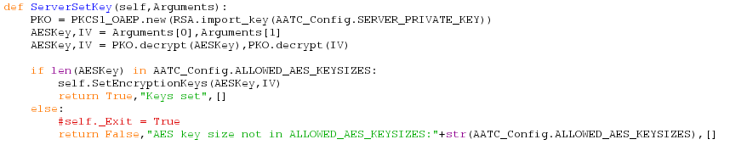
The ServerSetKey method is used as part of the RSA certificate key exchange system. The function takes the parameter Arguments which is a tuple containing AES and IV keys in encrypted form. To decrypt the keys the private RSA key of the server is loaded into an RSA object and used to decrypt the keys. If the AES key is of a length allowed by the server the keys are instated and a success response returned, otherwise a failure response is returned.

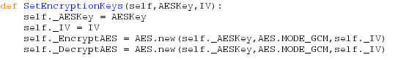
The SetEncryptionKeys method is used to setup the encryptions keys for the crypter object and initise the Encryption objects. As GCM takes into account the previous encryptions/ decryptions when an operation is performed unequal counters will cause the decryption to fail. Furthermore the pycryptodome module does not allow an AES object to be used for both encryption and decryption if the object has not been reset, therefore requiring seperate objects.

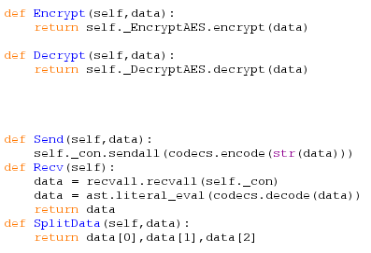
The Encrypt method takes a piece of data and returns the encrypted result.
The Decrypt method takes a piece of data and returns the decrypted result.
The Send method sends the data encoded via the socket.
The Recv method recieves data from the connection and returns the decoded , literal version.
Split data is used to split the data into Sucess,message and data.
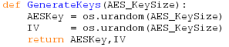
The GenerateKeys method takes one integer variable AES_KeySize and generates the AESKey and IV key using urandom, a cryptographically suitible random source, returning the keys.

